PILLI VENKAT KOUSHIK REDDY


HYDE

RABAD

,INDIA,5

0

00

90

91

21533491

pillikoushik20
17
@gmail.com

d
Koushik red

y

.
/LINKED
I

N

KOUHSIK71
0

4

CAREER OBJECTIVE
Seeking an entry-level Cybersecurity engineering role to apply my strong academic foundation and passion for coding. With a keen interest in cybersecurity, I am eager to contribute to secure, innovative, and high-impact projects while collaborating with dynamic teams. Committed to continuous learning, problem- solving, and refining my technical expertise to develop robust and efficient solutions.

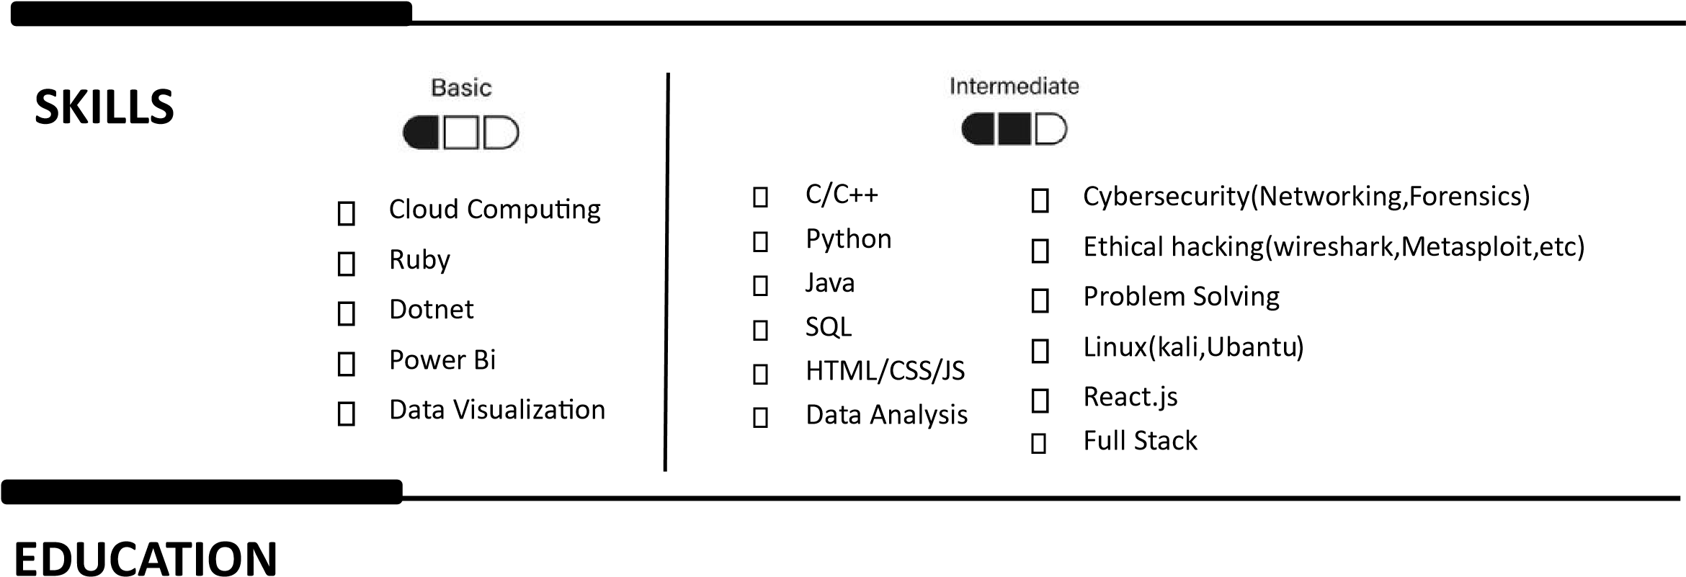
St. Peter’s Engineering college, Jntu Expected in 04/2027

Bachelor of Technology: Computer Science and Engineering(CyberSecurity) CGPA:73.45

Sankethika Vidhya Parshith (2019-2022)

Diploma in Electrical and Electronics Engineering CGPA:72.4

V T High School (completed in 2019)

SSC
GPA:75%

PROJECTS

AI VOICE DETECTER(https://github.com/Koushk7104/audio-Voice-Detector )
A AI working tool That and the report of the audio that we have given. This will help us to prevent the detects the Morphed audio that was mad by ai and gives the analyses scams calls and face audio threatening by using this tool by using ML in python we have developed this tool to detects the ai generated audios

Habito(The Habit tracking Application)( https://github.com/Koushk7104/Habito-the-gaming- )
This App allows the user to schedule their day with the gamification method and make their activities to be done in a habituation oriented manner. Developing this App can also be the mostly help for the users to get their things to be done in a funny way and engaging way so that user can also compete their tasks and get the rewards for that

Attendance Management System using Face Recognition

(https://github.com/Koushk7104/Attendance-Management-System-using-Face-Recognition )
The Attendance Management System is a Python-based application that leverages face recognition technology to automate the process of tracking student attendance. This project uses OpenCV for face detection and recognition,along with a user-friendly graphical interface built with Tkinter. It includes features for capturing images for training, real-time face recognition, and managing faces and mark their attendance and Capture and save images for training the recognition attendance records efficiently. Automatically recognize students' model. Option to manually fill attendance records and Generate attendance reports in CSV format and Store attendance records in a MySQL database.

Sentiment Analysis on Movie Reviews in IMDB REVIEW DATASET(Kaggle)
The project involves sentiment analysis of movie reviews using a Linear Support Vector
Machine (LinearSVC) classifier. The goal is to classify reviews as positive or negative based on text content. I'll train a model to achieve this classification.

SVASTHA(THE HEALTH CARD)( https://github.com/Koushk7104/healthconnectivity-hub)
Our idea is to create an app to store all the medical data of each person. Our idea is not only to store medical data like the prescriptions, tests, what the user is allergic to, their CT scans, X rays, etc. But also, stores the medical bills that were paid and the doctors they visited, which can be accessed easily and can be shared with whoever the user wants. Send the user notification to take medicines and test to be conducted.

Personal Data Breach Checker(https://github.com/Koushk7104/Personal-Data-Breach-Checker )
The Personal Data Breach Checker is a user-friendly web or mobile application that helps individuals determine if their personal information—such as email addresses, phone numbers, or usernames—has been exposed in data breaches. It leverages external APIs like HaveIBeenPwned (HIBP) or its own database to provide breach details and actionable security mendations. The app aims to improve cybersecurity awareness and encourage best practices like strong passwords and two-factor authentication (2FA). Core Features

Integrated Cybersecurity(https://github.com/Koushk7104/Integrated-cybersecurity)
Introducing a hands-on educational toolkit I built to demystify one of the most common cyber threats: phishing. Instead of just reading about security, this project lets you experience it safely. Analyzer: A tool to help you think like a defender and analyze suspicious links before you click. Phishing Demo Server: A simulation that shows exactly how your data can be stolen on a fake website. It's a real eye-opener! My mission was to create something that empowers everyone, regardless of their technical background, to be safer online. I believe education is our strongest defense.

Aegis(AI Bias Monitoring System)( https://github.com/Koushk7104/Aegis-AI-Bias-Monitoring-System-)
Project Aegis is an AI Bias Monitoring System designed to detect and visualize unfair decisionmaking in real time. It features a live CUI dashboard and a web interface where biased inputs can be simulated, recorded, and analyzed instantly.I contributed by developing the bias detection logic, integrating the Flask web app with the CUI monitor and we won the reward for this project in hackthon

CERTIFICATIONS/ACHIVEMENTS
- 2nd Winner of Avanya -2K25 HAckthon conducted by Anurag university - certificate
- Completed Python course – Datapro.
- Achieved certification in C and C++ courses – Datapro.
- Achieved certification in Java and adv Java -Datapro.
- Achieved Java explorer Batch from oracle university.
- Achieved certification in Java Data Structures Masterclass – udemy
- Solved all the Problems in hacker rank -Java & Python
- Attended workshop conducted by IITH on Ethical Hacking
- Participated in 36 hrs National level Hackathon24 conducted by St.Peter’s Engineering college
- Completed certification on Cyber security for everyone by university of Maryland - Coursera
- Completed certification on Data Analysis and Visualization with Power Bi by Microsoft -Coursera
- Achieved Software Engineer inter certification from HackerRank - HackerRank
- Achieved Python Certification from Hackerrank – HackerRank
- Achieved Java Certification from Hackerrank – HackerRank
- Achieved Problem Solving Certification from Hackerrank – HackerRank
- Achieved Ethical Hacking Certification from Cisco - Cisco
- Achieved Introduction of cybersecurity Certification from Cisco - Cisco
- Completed certification on Data Visualization with Tableau by University of California - Coursera
- Achieved the course completion certification on mastering python by Infosys – Infosys
- Completed certification on AWS Solutions Architecture Job Simulation by Amazon - Amazon
- Participated in starupedia’25 a startup Hackathon conducted by IPE(Institute of Public Enterprise)
- Completed the foundation of Cybersecurity by google – Coursera
- Achieved the certification on beginner level mysql in hackerrank – Hackerrank
- Achieved certified Ethical Hacker(CHE) by internshala - Internshala

INTERNSHIPS
- Completed 6 months of Internship at APSPDCL.(Diploma)
- Completed Internship on AI: Transformative Learning with TechSaksham – A joint CSR initiative of Microsoft & SAP,implemented by Edunet Foundation - Edunet
- Cybersecurity Intern BY redynox

